C229: Community Health and Population-Focused Nursing Field Experience
Heather Marshall
Western Governors University

Social Media Campaign on COVID-19
B.1 Covid-19 Health Disparity in Blue Earth County-Minnesota
Health disparity is a crucial concept that has been examined by several scholars. Health disparity can be defined as all forms of health differences that are associated with social, economic or even environmental disadvantages (Healthy People 2020, 2020). The onset and spread of coronavirus has proved the prevalence of health disparity in Blue Earth County to a greater extent. Such inequities imply that some people are able to manage or protect themselves from contracting covid-19 while others find difficulties in managing the same. The most common causes of health disparity in Blue Earth County are housing density and social distance and masks compliance. House density involves the number of homes in a given area. It is apparent that high density housing has many inhabitants as compared to low-density housing. Therefore, people living in high density housing areas are likely to contract covid-19 unlike those who lives in low-density housing in Blue Earth County. The main reason for such possibilities is that people in high-density housing usually have more face-to-face contacts thus making them potential hotspots for the spread of coronavirus (Hamidi, Sabouri, & Ewing, 2020). People in these high-density housing areas mostly violate social distancing measures hence risking their lives from contracting this deadly virus. Also, people who fail to wear masks while in public are at high risk of contracting coronavirus unlike those who abides to this health measure. Therefore, health disparity in relation to covid-19 is mainly caused by social, political, and environmental forces.
B 1 a. Primary Community and prevention resources for Covid-19 in Blue Earth County
The government of Blue Earth County has put up measures to enhance the safety of its residents. One of the strategies is coming up with an Emergency Assistance Program to help with utility expenses, rent, and mortgages to assist individuals in meeting daily needs during the pandemic. The program helps in settling shelter costs and other bills, including electricity and water. Also, the county has equipped health facilities with enough testing equipment to enable people to tests and also help in determining the trends of the pandemic. In terms of preventive resources, the county has provided Personal Protective Equipment, especially to Healthcare workers and police officers (Tuck, 2020). Such a segment comprises of personnel whose duties cannot be halted during the pandemic. Also, face masks and hand sanitizers have been made available to all residents to enable them to practice personal safety. Residents have also been advised to keep social distance and also start at home whenever they feel unwell. Again, the county came up with long-term care settings where visitors to health facilities must be screened and must wear a mask. The visitors are only allowed in the facilities if the facilities have had no Covid-19 case or exposure in the last two weeks.
1 b The Underlying Causes of the Covid -19
The Covid-19 (Coronavirus Disease-19) is caused by Severe Acute Respiratory Syndrome Coronavirus, commonly referred to as the SARS CoV-2 virus (Colmenero et al., 2020). The disease is under the virus family of Coronaviridae. Having stemmed from bats, the disease spread from the city of Huwan (China) after the contamination of human food (Colmenero et al., 2020). It then spread to all corners of the world, managing to sneak into the USA. Some of its symptoms include fatigue, coughing, difficulty in breathing, sore throat, and fever. The pandemic is spreading in the county because of the mingling of people with infected persons. The disease is contagious and spreads easily when one comes into contact with droplets of the cough or sneeze from an infected person. It also spreads when one comes into contact with infected surfaces. The disease can also spread easily through airborne transmission. Considering that the county opened some segments of the economy, there is a high rate of interactions between people from other counties and also at various workplaces (Colmenero et al., 2020). The most affected are youths who have to struggle and make ends meet. Another reason why the disease is spreading in the county is because of negligence by a segment of the population to put on masks and observe social distancing.
B2 Evidence-Based Practice Associated with Field Experience
In Blue Erath County, scholars in nursing and medical institutions have been at the forefront in performing the necessary field experience. The overwhelming intensity of the pandemic has strained the personnel. Also, a larger segment of doctors has not participated in the curing of the coronavirus, while others have decided to engage in thorough research about the disease (Colmenero et al., 2020). Only a countable number of doctors from Blue Earth County can stand to be counted as research analysts of the Covid-19 disease. Covid-19 can be prevented through several practices. One of them is regular sanitization by the use of an alcoholic-based sanitizer and regular washing of hands using clean running water (Colmenero et al., 2020). Also, it is wise to wear a mask while in public places to avoid inhaling droplets from an affected individual. It is also prudent to wear a mask because if infected, the mask prevents further spread to other individuals, especially during unavoidable interactions. Another strategy that can help prevent Covid-19 is limiting social interactions by observing social distancing. If possible, it is wise to work from home and also avoid unnecessary travels and interactions.
B2A Data on the Infection rates in Blue Earth County
Since the onsets of the pandemic, most of the cases were reflected in the people of color, especially the blacks, Asians, and those of Hispanic descent. Whites have been least affected by the pandemic. The following data are retrieved from the Blue Earth County Covid-19 case statistics (Blue Earth County, 2020).
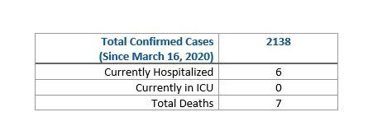
Records reveal that since March, the county has recorded 2138 cases with seven deaths.
Also, the most affected were youths from the age of 20 to 29 at 44.36%. The least affected were children from age 0 to 9 years (2.20%) and the elderly at 4.31%.
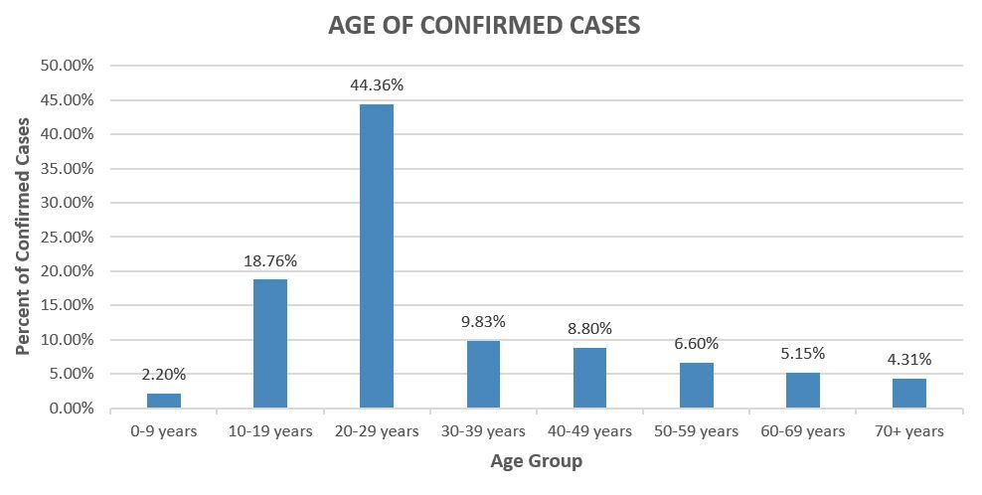

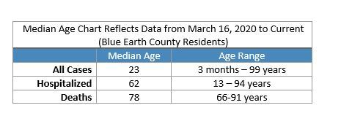
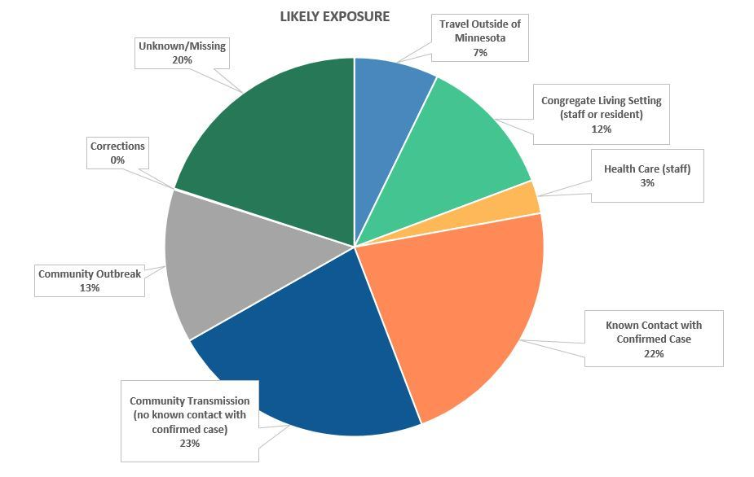

C The Social Media Campaign Strategy
C1 Objective of the social media campaign
The major objective of this social media campaign is to enhance a long-lasting and better relationship between the health department of Blue Earth County and the residents of the county. The target of the campaign is restricted to the state level, with the targeted population being the active social media users in the county. One of the Key Performance Indicators (KPIs) will be the influencer segment of the population. The group will consist of the social media followership of the county’s ministry of health. To add, the performance publication will encompass the elements of traction expected to be received by the shared campaign (Ali et al., 2020). In other words, the success of the campaign will be determined by the number of comments and likes from social media users. The campaign seeks to influence at least 90% of the targeted population, who should also positively influence others (Ali et al., 2020). Another objective of this campaign is to create awareness for the entire population in Blue Earth County on the challenges associated with Covid-19. For instance, this campaign will educate the general public on the dangers of Covid-19, which include loss of lives and damages of body organs such as lungs. The other objectives include teaching people on various measures that can be put in place to prevent the spread of Covid-19.
C2 Social Marketing Interventions
Social media intervention strategies have been used in Blue Earth County to create awareness on the prevention of the Covid-19 pandemic by the incorporation of behavioral theories. Amongst these behavioral change theories to be incorporated includes the social cognitive theory and the health belief theory. Through the use of these theories, social media interventions are employed in the analysis of the behaviors revealed by various individuals through the use of different social media platforms. One of the population-focused social marketing interventions is improving the quality and quantity of products necessary for handling Covid-19. This method would improve the health message relating to Covid-19 because the improvement in the quality of products such as personal protective equipment implies that people will trust such items and purchase more of them to handle the Covid-19 situation (Tan et al., 2020). Improving the quantity of these items means that all people will have access to them, thus protecting themselves from covid-19. Another intervention is providing masks free or at affordable prices. Through this intervention, all citizens from this county will finally protect themselves using the available masks that are effective for this situation.
C3 Social media platforms
A close look at the usage of social media platforms in the county reveals that Facebook and YouTube have a larger following in Blue Earth County (Peck, 2020). The two platforms will be used in the campaign so as to reach as many people as possible. The platforms will be used to showcase the proper way of putting on a mask, removing, and disposing it off. The message will have both written instructions and a video. Also, the best procedure of sanitizing hands using an alcoholic sanitizer and clean running water will be incorporated.
C3 A. Benefits of the platforms
The platforms (Facebook and Youtube) will enable the residents of the county to understand the main causes of the pandemic and also gain knowledge on how to prevent the spread of the virus by use of sanitization and wearing of masks (Malecki, Keating, & Safdar, 2020). The platforms are suitable because they have a larger user-base in the county. They also enable the users to have relevant explanations both in written and video form. To add, the platforms are easily accessible due to the cheapness and the availability of internet connectivity and the larger number of electronic gadgets that enable the use of Facebook and YouTube.
C4. How Target Population will benefit from the health message
The health message will benefit this target population because it will educate them on possible measures that should be taken to curb the spread of covid-19. Also, this message will enlighten these people on how to cope with this pandemic.
D Best practices
The implementation of the campaign on both Facebook and YouTube during marketing will incorporate a channel mix. The platforms will not only be launched on Facebook and YouTube but also on more prominent platforms, for instance, Twitter and television (Habes et al., 2020). In developing Facebook content, the relevant content will be kept short and simple for easy understanding. The length of the post will be 200 characters. This will allow the whole post to be viewed. Comments will be about 600 characters. In order to maintain an active account, posts will be made available every evening. The strategy will help acquire more active users. Also, all Facebook posts will have a single CDC URL that will be used to offer more details about the content. The link will be enhanced with the addition of custom images. Relevant promotional activities will also be conducted. They include the use of other media channels and asking users to like and even share the content. Another relevant element will be close monitoring of the Facebook page to enable timely response to comments and questions. The YouTube practices will include clearance and approval from the CDC and captioning of the videos. To add, the video content will be short, simple, and engaging. They will also have a CDC web link. The videos will be promoted via other platforms, for instance, CDC social media page. The videos will be free from technical hitches and will comply with section 508 of the CDC video standard.

E. Social Media Campaign Implementation

E.1 Stakeholders’ Role and Responsibilities in the Implementation
The first stakeholders will be the team responsible for the development of the campaign. Their duty will be coming up with the campaign strategy and redesigning it after the insights received from social media users after a campaign advertisement has been published. The social media marketing team, on the other hand, will be responsible for the identifications of probable social media platforms to be used in the campaign. They will similarly engage in responding to the users' comments, such as providing clarification if a user is uncertain about a concept in the campaign. The last most crucial stakeholders will be the sponsors who will fund the campaign through the period.

E.2 Public and Private Partnerships that will Aid the Implementation of the Campaign
Some of the Public partnerships that will aid the campaign are the County Government of Blue Earth, The Federal Government of the United States of America, in addition to the World Health Organization. Private partnerships may come from social media platforms that may be willing to create health awareness alongside local hospitals. The roles of these partners include the provision of technical and financial support to facilitate the entire process.

E. 3 Specific Timeline for Campaign Implementation
Table 1: Timeline for the Social Media Campaign Implementation
No. | Item | Week 1 | Week 2 | Week 3 | Week 4 | Week 5 | Week 6 | Week 7 | Week 8 | Week 9 | Week 10
1. | Recruiting the Campaign Team
2. | Campaign Strategy Development
3. | Social Media Platform Scrutiny
4. | Seeking Sponsorship
4. | Campaign Advertisement
5. | Redefining Campaign Strategy
6. | Official Launch of Campaign
7. | Monitoring and Maintenance
8. | Campaign Results Analysis
The first process will be recruiting a suitable team that will be responsible for the implementation of the social media campaign on COVID-19. This task shall be done in the first week, while the consecutive two weeks will be used in developing the social media campaign. The fourth week will be used by social media marketers to identify the variable social media platforms where the campaign will be launched. In the same week, after the variable social media platforms have been known, and a campaign has been developed, potential sponsors will be sourced to enable funding of the social media health campaign. This process will be extended to the fifth week, whereupon its completion and funds have been secured, the campaign will be advertised to gain insight into the perceptions and reactions of targeted users. After relevant information has been gathered, the social media campaign will be redesigned to avoid probable challenges faced during the advertisement during the 6th and 7th weeks. The social media campaign will be officially launched on the 8th week as the progress and performances are maintained and monitored in the 9th week. The last week will be used in conducting an assessment of the social media campaign's performance.

E. 4 Campaign Effectiveness Evaluation
One of the metrics that will be used to measure the effectiveness of the campaign is the increase in the number of followers on social media. The more followers the social media platforms used to run, the campaign will clearly reflect that the campaign targeted the right audience who are willing to gain more information from the social media platforms they follow. Another metric would be the number of reactions a campaign post receives. A larger number of comments or likes to a post interprets either people are interested in the contents of the campaign or are in agreement with the information being conveyed. Besides, social media platforms such as YouTube can indicate the reach of a campaign post, for instance, the number of views received in a single campaign video (Habes et al., 2020). This information will be able to assist the campaign team to identify the number of people the message has reached and from which part of the world while centrally focusing on Blue Earth County. In addition, referral traffic would also indicate clearly whether the campaign is successful. For instance, the more people share the social media campaign on their profiles, it exposes the message to a wide population located in their friend's list. This way, the campaign can use this metric to measure how effective the campaign was by focusing on the number of shares received in a single or all posts related to the COVID-19 campaign.

E. 5 Costs of Implementation
One probable cost is the aspect of maintaining originality whereby once the campaign has been launched and users have started interacting with it, a few individuals are likely to alter information conveyed or misinterpret the campaign's mission. It would be best to have the team responsible for social media marketing monitoring the outcomes to ascertain the original intentions of the campaign have been observed (Habes et al., 2020). Should there be a lack of funding; the campaign may not be as successful as anticipated. Some of the potential costs in this context include paid advertisements on Facebook and YouTube pertaining to Covid-19 and the cost of managing employees or staff.

F. Reflection on How Social Media could Promote Healthier Populations
Social media could promote healthier populations by making its users more cautious about health precautions based on the information they receive on the platforms (Lopez & Cleary, 2018). In addition, the aspect of self-realization will be noticed since users may begin to realize some of the health changes occurring in their bodies based on the descriptions given by certified physicians on the social media platform. This way, users are likely to seek medical assistance once they notice a change in their health, which is far from their wellbeing norm. The community health nurse can use social media to create awareness regarding other health problems such as HIV/AIDS. For instance, the nurse can create a WhatsApp group or even hold zoom meetings with people in order to teach them how to curb the spread of HIV/AIDS.

F1. Impact of Social Media Campaign in Future Nursing Practice
Social media campaigns could assist in future nursing practice by allowing nurses to gain access to huge and unlimited access to information (Lopez & Cleary, 2018). Besides, social media could enable future nurses to interact both on a personal and professional level with their prospective patients. This way, nurses can assist patients who have been hospitalized in their homes to self-medicate themselves in the absence of a professional medical practitioner. I can use social media in my future nursing program to study the lifestyle of people and use such findings to identify the causes of certain lifestyle diseases in the community. For instance, I can observe daily posts of people in the media, including meals, and analyze the risk factors associated with such foods.

References
Ali, S. H., Foreman, J., Capasso, A., Jones, A. M., Tozan, Y., & DiClemente, R. J. (2020). Social media as a recruitment platform for a nationwide online survey of COVID-19 knowledge, beliefs, and practices in the United States: methodology and feasibility analysis. BMC medical research methodology, 20, 1-11.
Blue Earth County. (2020). County COVID-19 Case Statistics | Blue Earth County, MN - Official Website. Retrieved 3 November 2020, from https://www.blueearthcountymn.gov/1538/County-COVID-19-Case-Statistics
Colmenero, I., Santonja, C., Alonso‐Riaño, M., Noguera‐Morel, L., Hernández‐Martín, A., Andina, D., ... & Torrelo, A. (2020). The SARS‐CoV‐2 endothelial infection causes COVID‐19 chilblains: histopathological, immunohistochemical, and ultrastructural study of seven pediatric cases. British Journal of Dermatology.
Habes, M., Alghizzawi, M., Ali, S., SalihAlnaser, A., & Salloum, S. A. (2020). The Relation among Marketing ads, via Digital Media and mitigate (COVID-19) pandemic in Jordan. International Journal of Advanced Science and Technology, 29(7), 12326-12348.
Hamidi, S., Sabouri, S., & Ewing, R. (2020). Does density aggravate the COVID-19 pandemic? Early findings and lessons for planners. Journal of the American Planning Association, 1-15.
Healthy People 2020. (2020). Disparities | Healthy People 2020. Retrieved 3 November 2020, from https://www.healthypeople.gov/2020/about/foundation-health-measures/Disparities
Lopez, V., & Cleary, M. (2018). Using social media in nursing education: an emerging teaching tool. Issues in mental health nursing, 39(7), 616-619.
Malecki, K., Keating, J. A., & Safdar, N. (2020). Crisis communication and public perception of COVID-19 risk in the era of social media. Clinical Infectious Diseases.
Peck, L. (2020). Yesterday is History: Using Communications to Grow Attendance at Hennepin History Museum.
Tan, L., Kovoor, J. G., Williamson, P., Tivey, D. R., Babidge, W. J., Collinson, T. G., ... & Maddern, G. J. (2020). Personal protective equipment and evidence‐based advice for surgical departments during COVID‐19. ANZ Journal of Surgery, 90(9), 1566-1572.
Tuck, B. (2020). Minnesota’s Economy and COVID-19.

